
Delicious Pear and banana scones

What’s not to like about a scone on a cold winter day…or any day!? These scones are not only satisfyingly delicious, they are baked with no added sugar getting the sugars from the pear and banana. You won’t miss the added sugar, give them a try!
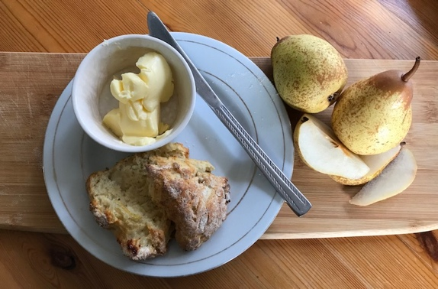

You could add other fruits, spices and also nuts if you wanted depending on what is in season.

Pears are lovely just now and there are so many great things to make with them. Use with skins on for extra fibre!

The scones are super quick to make and the kids could help too!

Ingredients  - 225g self -raising flour (spelt or wholemeal flour could also be used, you just need to add in a teaspoon of baking powder with it, or you could combine a couple of different flours) plus extra for dusting  - 55g softened butter  - 1 teaspoon bicarbonate of soda  - 1 small pear washed and grated  - 2 tablespoons natural yoghurt or buttermilk  - Half a ripe banana  - Approx. 3 tablespoons milk (at room temp)  Tip: when baking, make sure all ingredients are at room temp | Directions  - Preheat the oven to 240°C/fan 220/475°F/gas 8.  - Place flour and butter in a large bowl and rub with fingertips until all butter is rubbed through. Add in bicarbonate of soda and mix.  - Break banana into small bits and rub into mixture gently.  - Beat the yoghurt/buttermilk and milk together in a separate bowl.  - Mix in the grated pear until well combined.  - Add yoghurt mix into the flour with a fork, then use your hands to bring the dough together. Do not over work.  - Cut with a scone cutter or cut into triangles.  - Place on floured oven tray.  - Bake for 15minutes.
Image by Nutrition Scotland
Tell us if you liked it! @nutritionscot  @nutritionscotland

