
Juicy Beetroot burgers

Who would have thought you could make a burger out of a beetroot! This is a great way of increasing you veg and fibre intake using seasonal veg. It is easy to make and the colour is great! They are also tasty eaten cold with a salad! You can add seeds, spices, nuts or other veg to add flavour!
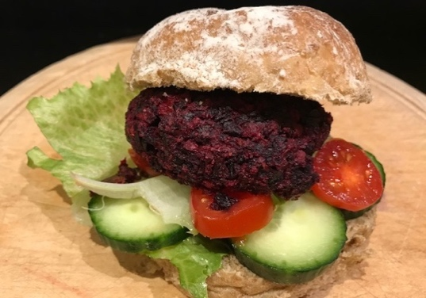
Beetroot contains:
- Manganese which contributes towards the maintenance of healthy bones and helps protect cells from damage
- Folate - help reduce tiredness and fatigue and essential for healthy development of the baby in the early stages of pregnancy
- Potassium - supports everyday functioning of our muscles and nervous system

Ingredients  - Two beetroot and 2 carrots (about 600g in total combined) washed (skins on if okay) chopped into cubes  - 1 red onion – chopped into 4 chunks  - 2 cloves garlic – skin off left whole  - 1 tsp ground coriander  - 1 tsp ground cumin  - 50-60g fresh breadcrumbs  - 1 egg beaten  - Wee bit of olive oil | Directions  - Preheat the oven to 220°C/fan 200/345°F/gas 7.  - Place all veg on a tray and drizzle with a wee bit of olive oil. Sprinkle spices on top and mix well. Roast for 25- 35 mins or until cooked.  - Cool. Then blitz in a blender or use hand blender to chop down to smaller bits.  - Add in egg and breadcrumbs and mix well.  - Shape into a ball and flatten out with hand to about 2 inches thick.  - Put in fridge to chill for about 15mins if possible. Then oven cook on greased tray for about 20 minutes.
Image by Nutrition Scotland

Tell us if you liked it! @nutritionscot  @nutritionscotland

