
Scrumptious Apple and Walnut soda bread

Soda bread is a great way of having tasty bread to eat without all the hassle of waiting for the dough to rise, its quick and easy to do! Enjoy with one of our tasty soups or just on its own!

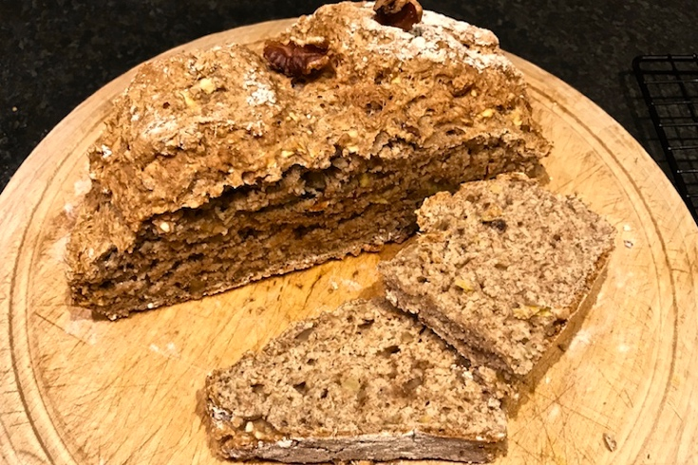
Once you have the basic recipe, you can adapt it to your own likes. You can experiment by adding seeds, herbs, spices, nuts, fruit or veg to add to the flavour!

Using whole grain flours will also make it a healthier option!

Ingredients  - 250g spelt or wholemeal flour  - 100 g plain flour plus extra for dusting  - 50g oatmeal or grind up porridge oats  - 1 teaspoon bicarbonate of soda  - 1 large free-range egg  - 300 ml natural yoghurt or buttermilk  - Teaspoon salt  - 40g chopped walnuts (or other nuts and seeds)  - 1 apple grated with skin on (or other fruit and veg) | Directions  - Preheat the oven to 190°C/fan 170/375°F/gas 5.  - Place all dry ingredients in a large bowl and mix together.  - Beat the yoghurt/buttermilk and egg together in a separate bowl.  - Stir the egg mixture into the flour with a fork, then use your hands to bring the dough together.  - Shape into a ball and flatten out with hand to about 3 inches thick. Place on floured oven tray.  - Score a cross into the top of the bread. Bake for 50 to 60 minutes, or until a dark crust has formed. It should sound hollow when tapped on bottom.
Image by Nutrition Scotland

Tell us if you liked it! @nutritionscot  @nutritionscotland

